Using backspace to remove text

missing

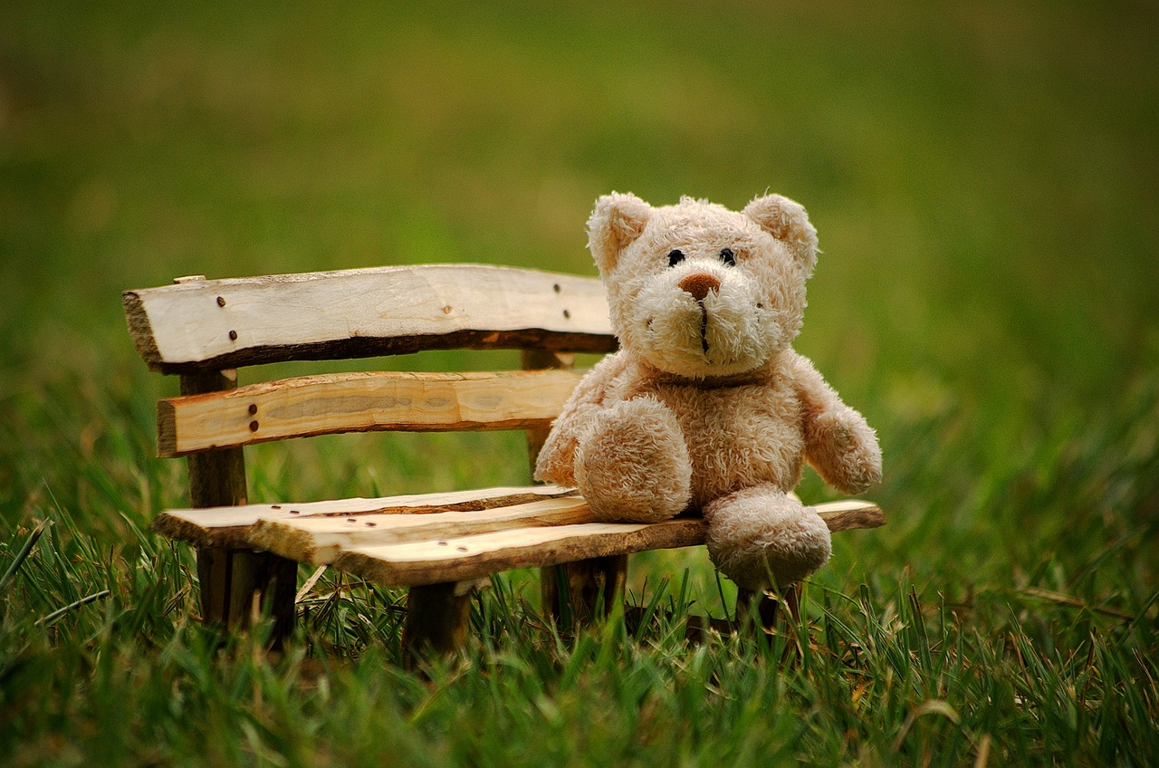

this is ted. he has two black eyes. ted has soft green fur. ted is small.

Call 01234 594302

Image source: https://pixabay.com/photos/teddy-soft-toy-funny-teddy-bear-2977694

This resource is available online at ncce.io/cm1w-2-a4-r. Resources are updated regularly — please check that you are using the latest version.

This resource is licensed under the Open Government Licence, version 3. For more information on this licence, see ncce.io/ogl.

