12.01.2021 Level 2
LI: To find the difference between two numbers
Steps to success:
- I can find the difference by solving problems using numbers up to 10. (Level 1)
- I can find the difference by solving problems using 1 and 2 digit numbers. (Level 2)
- I can find the difference by solving problems using the most efficient method to help me. (Level 3)
Reasoning and problem solving: can you explain your answers?
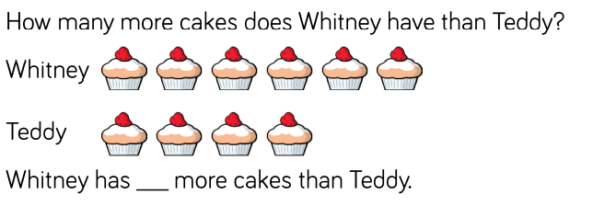

- What’s the difference between 20 and 16?

The difference between 20 and 16 is _____

20 – 16 =

- Eva has 17 sweets and Mo has 13 sweets.
How many more sweets does Eva have?

Eva has ____ more sweets than Mo.

The difference between 17 and 13 is ____

- Joe has 19 stickers and Bill has 7 stickers.
How many more stickers does Joe have?

Joe has ____ more stickers than Bill

The difference between 19 and 7 is ____

- Two numbers have a difference of 4

The larger number is less than 20.

What could the two numbers be?

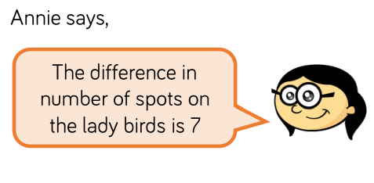

Write a number sentence to show why Annie is correct.

- True or False?

Rosie says
The difference between 27 and 14 is 13.

How do you know?

