13.01.2021 Level 2
LI: To find the difference between two numbers
Steps to success:
- I can find the difference by solving problems using numbers up to 10. (Level 1)
- I can find the difference by solving problems using 1 and 2 digit numbers. (Level 2)
- I can find the difference by solving problems using the most efficient method to help me. (Level 3)
Reasoning and problem solving: can you explain your answers?

Remember! Think about the most efficient method to use. Will it be easier to count on or count back?

What is the difference between?
1
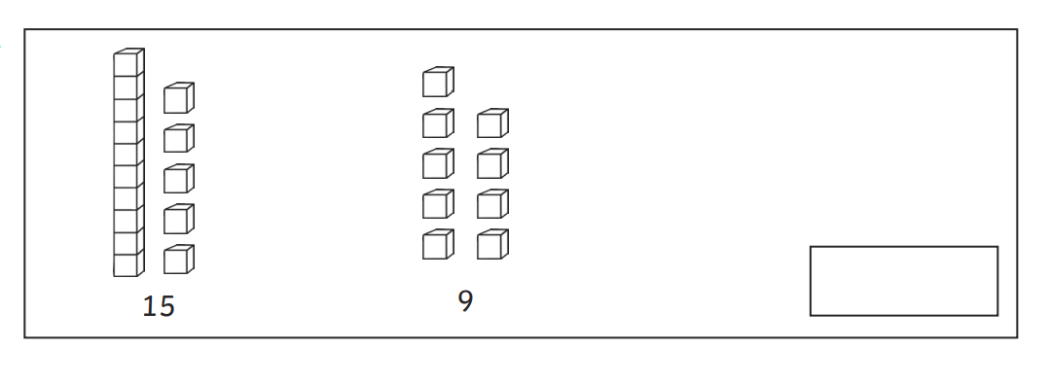

25

2
What is the difference between?

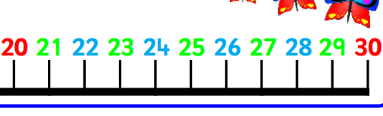

What is the difference between…?
3

- 3 and 15 _____ c. 16 and 19_____

- 15 and 20_____ d. 21 and 28_____

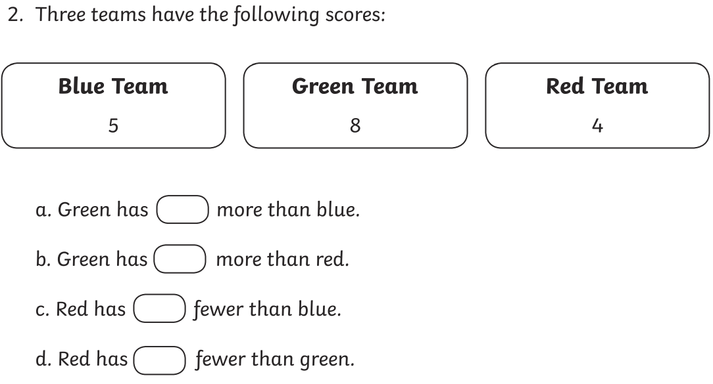
4

14
18
15

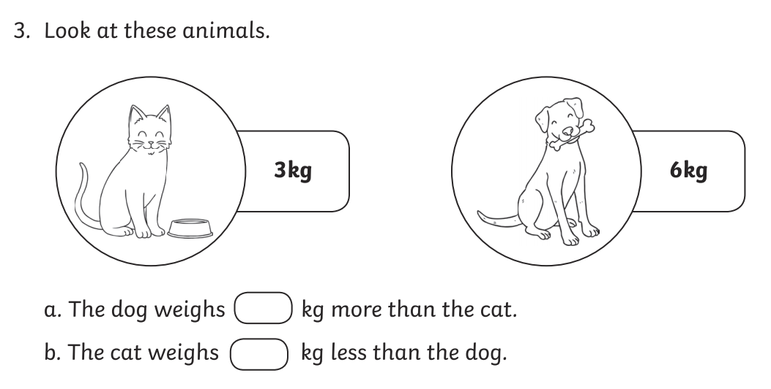
5
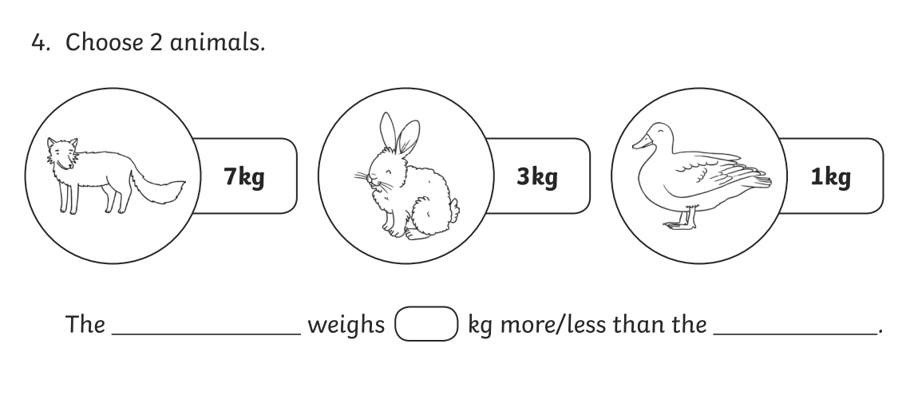
16
13

6
Jenny has 22p and Thomas has 5p. What is the difference between the amounts of money Jenny and Thomas have?

7

11
13
17

8
Mariam is 27 years old and Usman is 16 years old. What is the difference in age between Mariam and Usman?

9

William weighs 2 empty boxes. One weighs 29 grams and the other 12g. What is the difference between the masses of each box?

