English Unit Plan
Experience day:
Writing lesson - plot point 4:  Can I write effective sentences for our story 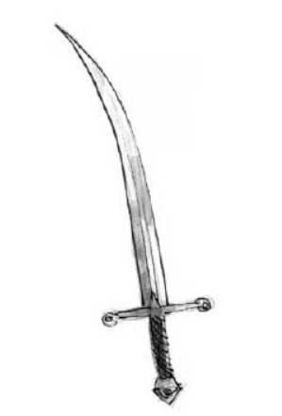 |  |  | Steps to success
FANTASTICs

Grammaristics | 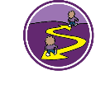
Boomtastics | Please copy and paste the Writing Rainbow Symbols into the relevant boxes.
Initiate |  | Model |  |  | Enable
The next day, Tommy arrives at the armoury and hears crying… Sir Walter’s sword is missing. Thesaurus thinking crying words. |  | The following morning, Tommy arrived at the armoury and heard sniffling.” What is wrong?” She asked the Old swords.  “Reynard has stolen Sir Walter’s sword. He is trying to get you fired.” |  |  | Children to write a sentence describing the swords crying and another sentence explaining why they are sad.
Use pathetic fallacy to emphasize the mood change in Tommy.  Author example: It was a dull day. The grey of the sky meeting the grey of the sea on the horizon. (Michael Morpurgo A medal for Leroy). Explore weather and cloud adjectives. |  | It was a worrying day. Clouds gathered, the sky turned a gloomy dark. |  |  | Children to write two sentences. A short sentence describing the day and a long sentence describing the weather.
Use a fronted adverbial and describe how Tommy goes about finding the sword. Remind children that Tommy is brave and courageous. |  | Quickly, Tommy hurries out of the Armoury. No time to lose. She has got to find the sword and save her job. |  |  | Children to write a sentence starting with a fronted adverbial.

English Unit Plan
Experience day:
Writing lesson - plot point 5:  Can I write effective sentences for our story  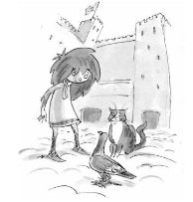 |  |  | Steps to success
FANTASTICs

Grammaristics
Boomtastics | Please copy and paste the Writing Rainbow Symbols into the relevant boxes.
Initiate |  | Model |  |  | Enable
Tommy is looking for the cat to see if it saw Reynard hiding the sword.  What questions could Tommy ask the cat? |  | Tommy spotted the castle cat in a shadowy corner of the courtyard. The swords told me Reynard stole Sir Walter’s sword. Have you seen him? Do you know what he did with it? |  |  | Children can magpie the step sentence. Write their questions for the Castle Cat.
The cat didn’t see anything, but luckily the post pigeon did.  Remind children of -ed rule when we put verbs in the past tense. List noticing words in the past tense. Use thesaurus thinking (saw, spotted, watched). |  | The cat didn’t see anything. ”I saw what happened, “ said the post pigeon, “I know where he hid the sword.” |  |  | Children to write what the pigeon saw. Using their own noticing words in the past tense.
Reynard threw the sword in the moat. How can we describe the moat using alliteration? List words: muddy, murky, majestic, maroon, magnificent, makeshift, mammoth, manky, … |  | “I saw him throw the sword into the murky, mammoth, manky moat very early this morning.” |  |  | Children to write one sentence with at least to adjectives describing the moat.

English Unit Plan
Experience day:
Writing lesson - plot point 6:  Can I write effective sentences for our story  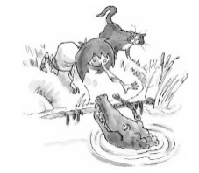 |  |  | Steps to success
FANTASTICs

Grammaristics
Boomtastics | Please copy and paste the Writing Rainbow Symbols into the relevant boxes.
Initiate |  | Model |  |  | Enable
Tommy arrives at the moat with the Castle Cat. The moat is really smelly. Thesaurus thinking negative smells. |  | Tommy and the cat arrived at the moat. Urgh, what a stench! |  |  | Children to write at least one sentence describing how smelly the moat was.
The cat tells Tommy a crocodile lives in the moat. They can ask him if he can find the sword for her.  How can we persuade the crocodile to find the sword? |  | Sir crocodile (or choose a name with class), please can you find Sir Walter’s sword for us? We would be ever so grateful and give you a nice juicy rat. |  |  | Children to write their own persuasive sentences.
Thesaurus thinking words that show Tommy is moving fast. (running, racing, darting) |  | Here’s your sword. Now you better hurry and return it quickly. Tommy darted across the drawbridge back to the Armoury. |  |  | Children to write their own fast paced sentence showing Tommy returning to the armoury.

English Unit Plan
Experience day:
Writing lesson - plot point 7:  Can I write effective sentences for our story  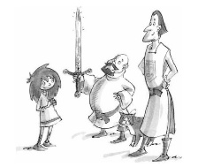 |  |  | Steps to success
FANTASTICs

Grammaristics
Boomtastics | Please copy and paste the Writing Rainbow Symbols into the relevant boxes.
Initiate |  | Model |  |  | Enable
Gather ideas: what can we hear if we hear people approaching? How might that have sound in a castle? |  | Just in time, Tommy cleaned and returned Sir Walter’s sword to its place. She could hear voices coming near and footstep approaching. |  |  | Children to write at least one sentence describing the sound they might hear.
Sir Walter is really pleased to see his sword gleaming. What do you think he might say to Tommy? |  | Sir Walter entered the Armoury. Tommy curtsied.  “Ah, my sword is looking mighty fine. Thank you for looking after it so well.” |  |  | Children write their own dialogue sentence(s).
What do you think Tommy is feeling now? List on board. Can we come up with a simile to emphasise this feeling the reader? |  | Tommy was proud as a peacock. |  |  | Children to write their own simile sentence to end the story.

Independent write
Day 1 - Friday
Explain children are now going to plan their own adventure story featuring Tommy and set in Flamant Castle.
They will use seven plot points and need one lens for each plot point.
Which lenses are you going to use? Discuss why? Make sure children challenge themselves. They can choose lenses they feel confident about and some that may be tricky to use.
Then give them a blank planner with the correct number of plot points. Reinforce that plot points make a paragraph and they need a step sentence either at the end of a plot point or at the start of a new one to create cohesion.
Children to complete the blank planner and indicate where they are going to use each lens.

