Year 3 Fluency Ordering numbers

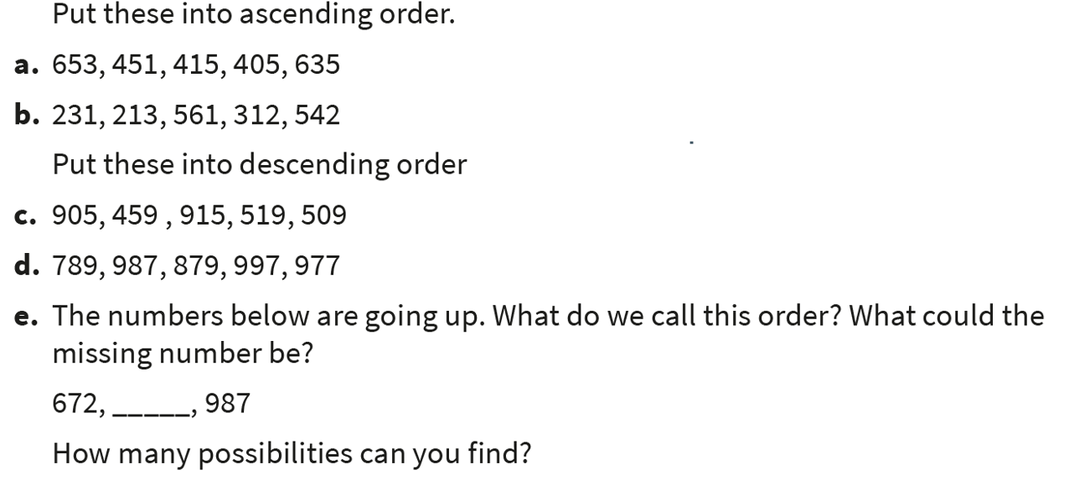

Year 4 Fluency Ordering 4-digit numbers

