Wednesday 4th November 2020

Dear Diary,

Today, I went to the dentist because of my bad tooth. It hurt so much!

Before I went, I brushed my teeth as hard as I could.

At 3pm, I finally went to the dentist. I absolutely hate the dentist. I mean, who does like the dentist?

A little while after I arrived, Mr Erstwhile called my name loudly. He looked like a really old man and wore really thick glasses that made his eyes look like tennis balls.

As soon as I sat in the chair, he took one look at one of my really bad teeth and told me it had to come out! I was horrified! First, he tried to take it out but it wouldn’t work. Then, Miss Veal tried to take it out by tying floss around my tooth and falling out of a window, but it still wouldn’t work. Finally, as I was lying in terror, Mr Erstwhile took a large swig of mouthwash, gripped tight, and yanked my tooth out! I was in so much pain! I still am.

I hope I never go to a dentist ever again! How could I after all of that?

Alfie
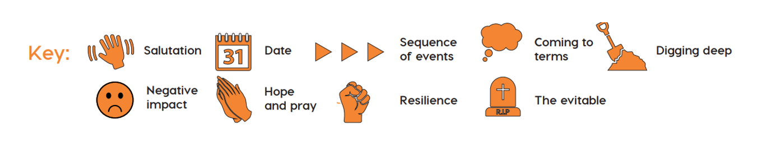
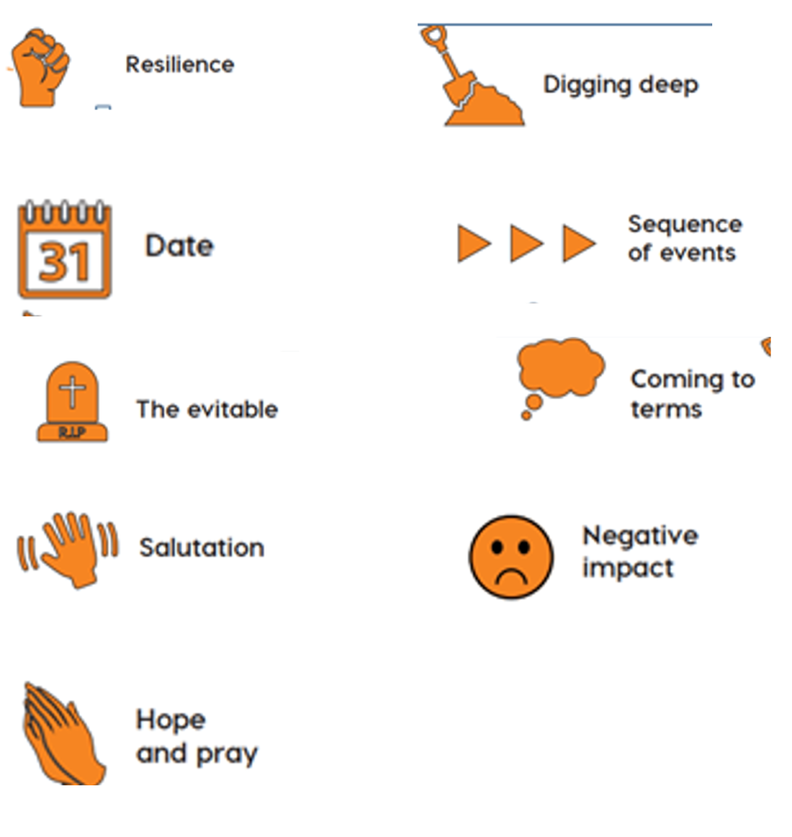

How do you feel when you have to go to the dentist?
Do you like it?
Are you scared?
How do you think Alfie was feeling?

What other time conjunctions can you use?
Describe the dentist office. Use two adjectives.
What is Alfie feeling?

What other -ly words can you use to open this sentence?
How is Alfie going to walk into the treatment room?
How will he sit in the chair?
What is he feeling?

“Ah, bad tooth, I see”, Mr Erstwhile mumbled, “A filling can’t save it. It’ll have to come out.”
What do you think Alfie replied in response?
What did he do?
Use a simile to describe how scared he must have felt.

The dentist yanked and yanked and yanked with his huge steel forceps. But the tooth wouldn’t come out.
Use the power of three to describe what happened next.
Miss Prigg – dental nurse, Miss Veal – receptionist, eight patients from the waiting room.
Add a rhetorical question.

Finally, after what seemed like days, weeks, even months of yanking my tooth came out with a loud crunch.
Start your sentence with a feeling word.
Finish with a ‘Looking ahead’ sentence.

Informal, chatty
Date
Looking back and ahead
past tense
first person
rhetorical questions
preposition of time

