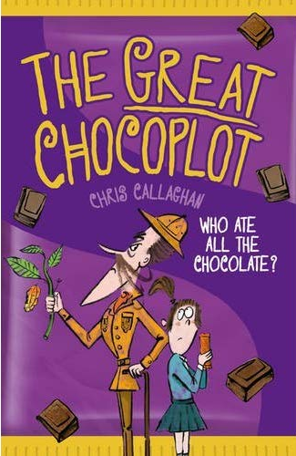
The Great Chocoplot –
Chris Callaghan Chapter 2
Jelly wondered if there was any more chocolate downstairs. Sometimes there was an Ice Choc hidden in the freezer behind the frozen broccoli. But no-there wasn’t even any frozen broccoli to hide behind.
Gran, Jelly suddenly thought. She’d definitely have chocolate.
Gran lived in an old caravan on the drive. The Gran-o-van, they called it. She’d lived there for about a year, since Grandad had died. There wasn’t enough room for her in their small stone terraced house, which had been built over one hundred years ago, and the caravan was all they had been able to afford. It was a really old pumpkin-shaped one with a date on its side showing it was even older than dad, and it was covered in a patchwork of repairs and rust-coloured stains (just like Dad). Still, Gran loved it. She said it was like being on an adventure, and that one day the Gran-a-van would magically turn into a golden coach and whisk her off to a fancy ball.
Jelly rapped on the caravan door.
‘Friend or foe?’ came a voice from inside.
‘Grandaughter!’ giggled Jelly.
After a few moments, the door opened and Gran’s wide grin greeted her, along with a waft of the caravan’s musty smell.
‘Friend, definitely a friend,’ she said, taking her headphones from around her neck.
You could always hear the motorway noise through the thin metal walls of the Gran-o-van, and so Gran wore her trusty headphones most of the time, even though they made her look like some kind of OAP rapper.
‘Did you see the funny thing on the telly about the world running out of chocolate?’ asked Jelly, moving a book from the worn sofa so she could sit down.
‘No dear, I’ve been reading. In between snoozes. But if that’s the case dear, take your pick before they all disappear!’
Jelly chose a Blocka Choca bar from Gran’s special chocolate drawer.
‘What are you reading, Gran?’ Jelly asked as they chomped away. She turned the pages of the book next to her. It looked very weighty and serious, bound in a tatty red leather without even a picture on the front.
‘Oh, that old thing?’ Gran said. ’It’s nothing. I’m just being nostalgic and silly.’
‘The Positive in the Negative by A.T. Curtin.’ Jelly spotted a familiar name.
’That’s you! Did you write this?’
‘It was the last thing I wrote as a scientist before your mother was born, gave it all up to bring up the children and I did it gladly.’
‘What kind of things did you do in your lab?’ asked Jelly, breaking off another chunk of Blocka Choca.
Gran smiled and gently ran her fingers across her printed name. For just a moment she looked different somehow- whether it was pride or sadness, Jelly couldn’t quite tell.
‘I was part of a research team in London. Our research centre was just around the corner from Ten Downing street, you know.’
‘So what did you do there?’ said Jelly, leaning forward.
‘We carried out research and experiments to confirm that something didn’t work.’
‘That something didn’t work?’ asked Jelly, confused.
Gran laughed. ‘I suppose it sounds quite loony when you say it out loud! But sometimes that’s science for you.’

