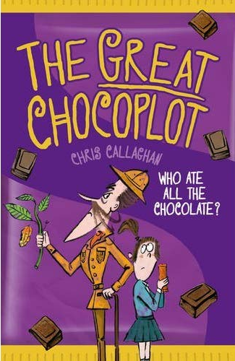
The Great Chocoplot –
Chris Callaghan Chapter 2

Jelly wondered if there was any more chocolate downstairs. Sometimes there was an Ice Choc hidden in the freezer behind the frozen broccoli. But no, it was empty.
Gran, Jelly suddenly thought. She’d definitely have chocolate.
Gran lived in an old caravan on the drive. The Gran-o-van, they called it. It was a really rusty, old pumpkin-shaped one with a date on its side showing it was even older than dad, Still, Gran loved it.
Jelly rapped on the caravan door. Gran opened the door wearing headphones.
‘Did you see the funny thing on the telly about the world running out of chocolate?’ asked Jelly, moving a book from the worn sofa so she could sit down.
‘No dear, I’ve been reading. But take your pick before they all go!’
Jelly chose a Blocka Choca bar from Gran’s special chocolate drawer. They sat chomping on their chocolate bars with the sound of the motorway outside filling their ears.

