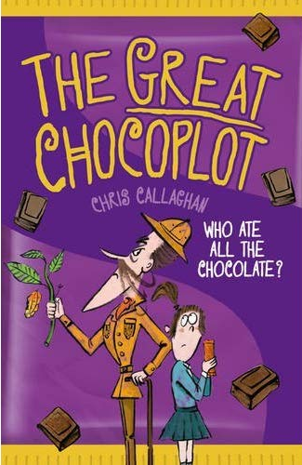
The Great Chocoplot - Chris Callaghan
“In six days there will be no more chocolate in the world… ever!”
That’s what is said on The Seven Show. Jelly had nearly reached the next level of Zombie Puppy Dash, but hearing this made her plunge the pink puppy into a huge tank of zombie dog food.
“Woah! What was that about chocolate?” she asked, putting her tablet down.
“Something about it running out,” said Mum, popping a chunk of chocolate into her mouth. “Oh, you can’t beat a Blocka Choca, eh!”
Jelly and her mum and dad loved Blocka Chocas. Who didn’t? Once a week Mum bought one bar for each of them, and they all curled up on the sofa together to enjoy them before mum started her night shift at the supermarket.
“Chocolate’s always mysteriously running out in this house,” said Dad, who’d already finished his Blocka Choca and was now eating cheese and onion crisps. “I’m sure there was a Chunky Choc-Chip Crispie in the cupboard yesterday, but today it has vanished!”
“I don’t know why you’re looking at me,” Mum said, poking him in the belly, which was stretching the buttons of his checked shirt to the limit.
“Oh that’s right, blame me.”
“I do.”
“Good!”
“Good!”
“Ssh!” said Jelly. “I’m trying to listen!”
The Seven Show’s chirpy and very tanned presenter Alice was saying, “And now over to our man in the jungle and the scary chocolate prophecy!”
The screen cut to a lush green tropical paradise, like Jelly had seen on documentaries about endangered species, or advertising a holiday her parents could never afford.
The caption on the screen read ‘Easter Egg Island’, and the reporter was a man called Martin who had a wonky but fake-looking smile which always made Jelly lick her front teeth and wonder if hers were as white and shiny. He did the silly bits on the show, like the old steam train found buried on a beach in Wales and the dog that fell in love with an owl. Today, he was standing next to an old man with wild, grey hair that was stuck up in patches.
Behind them, was what looked like a huge stone egg, twice the height of Jelly’s dad and covered in jungle vines. It looked like it had been sprayed with green party streamers.
“Thank you Alice,” said Martin, “I’m here on Easter Egg Island. This is the little island in the middle of the Atlantic Ocean – not Easter Island in the Pacific, folks.” He chuckled. “Here with me is chocolate expert Professor Fizziwicks from the University of Cambridge. He is convinced that he has discovered a prophecy by an ancient civilization which once lived here and, if you can believe it, worshipped chocolate!”
The camera zoomed in to the egg-shaped stone. It was covered with weird-looking marks and scratches.

