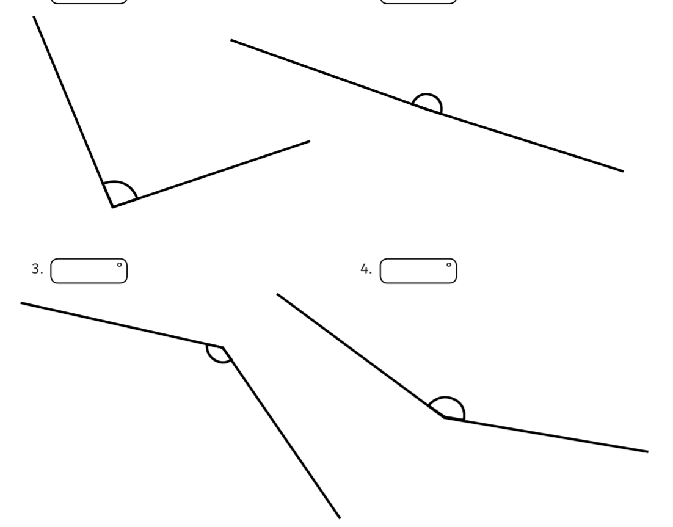

Bronze (2) – Measure these angles using a protractor and write the size of the angles using ° in your answer.



Bronze (2) – Measure these angles using a protractor and write the size of the angles using ° in your answer.

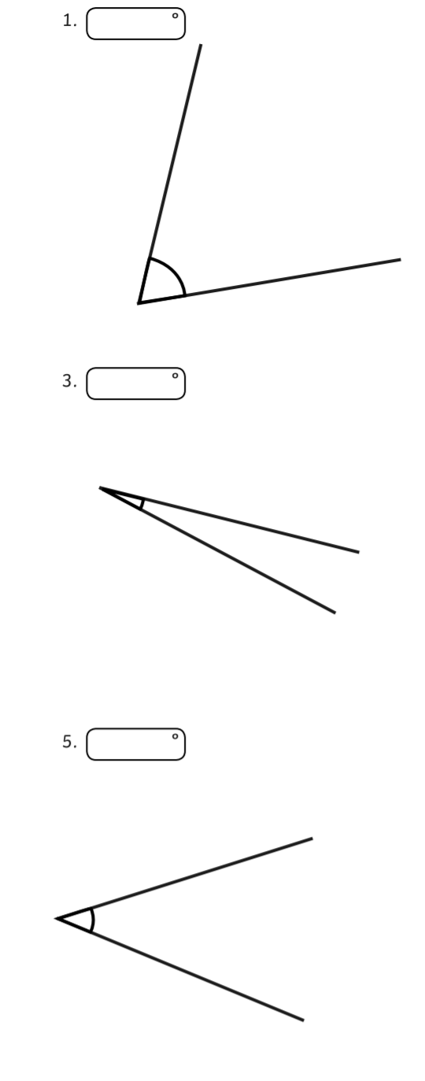

Bronze (1) – Measure these angles using a protractor and write the size of the angles using ° in your answer.



Bronze (1) – Measure these angles using a protractor and write the size of the angles using ° in your answer.