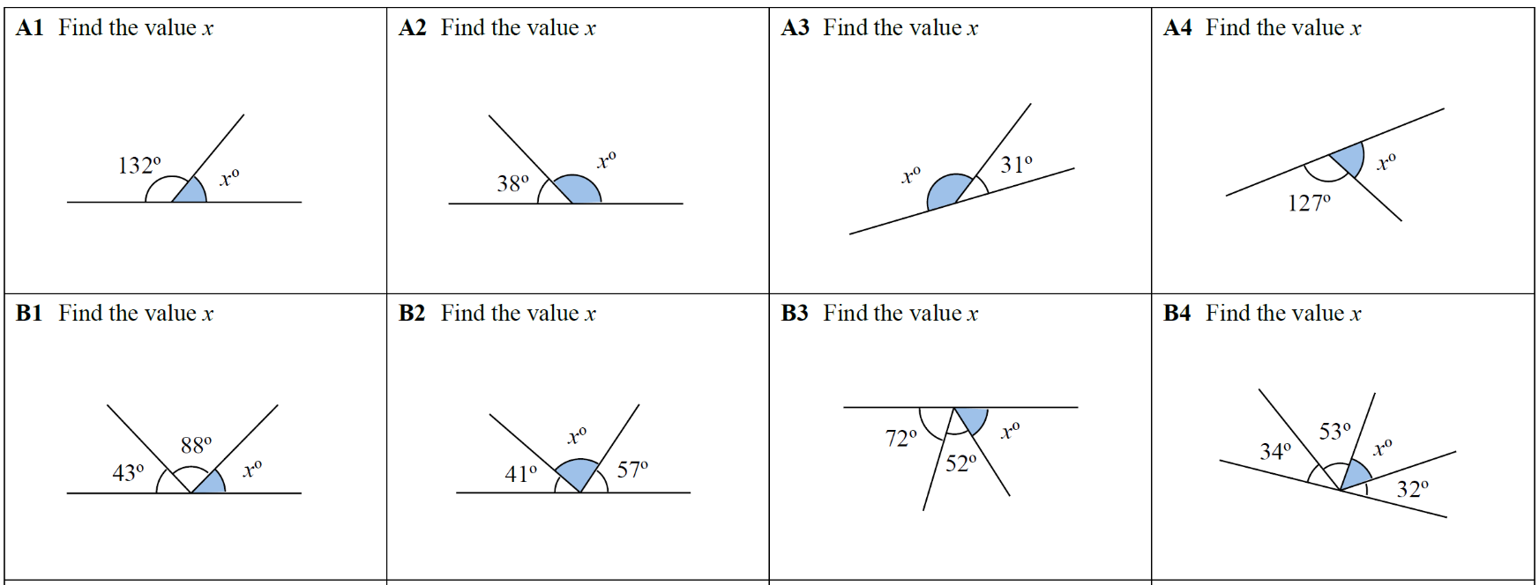

Year 5 Bronze



Year 5 Bronze



Year 5 Bronze