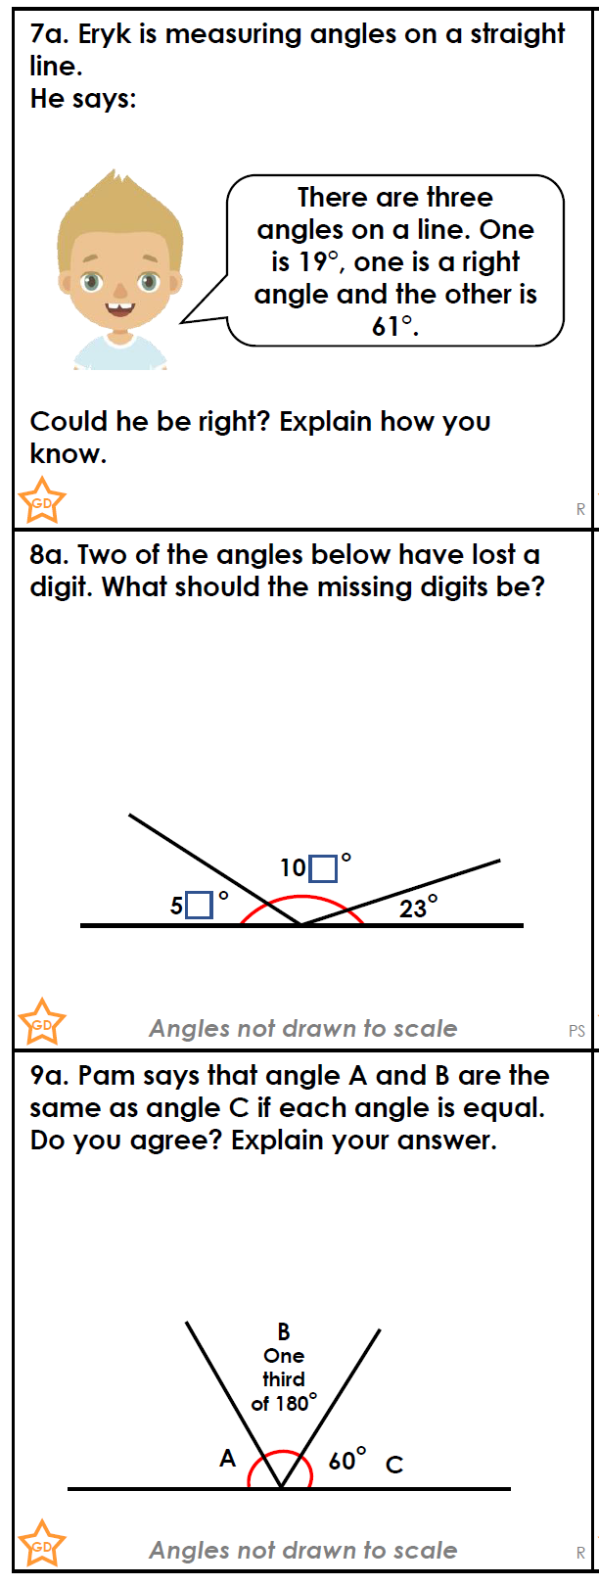

Year 5 Silver

Year 5 Silver