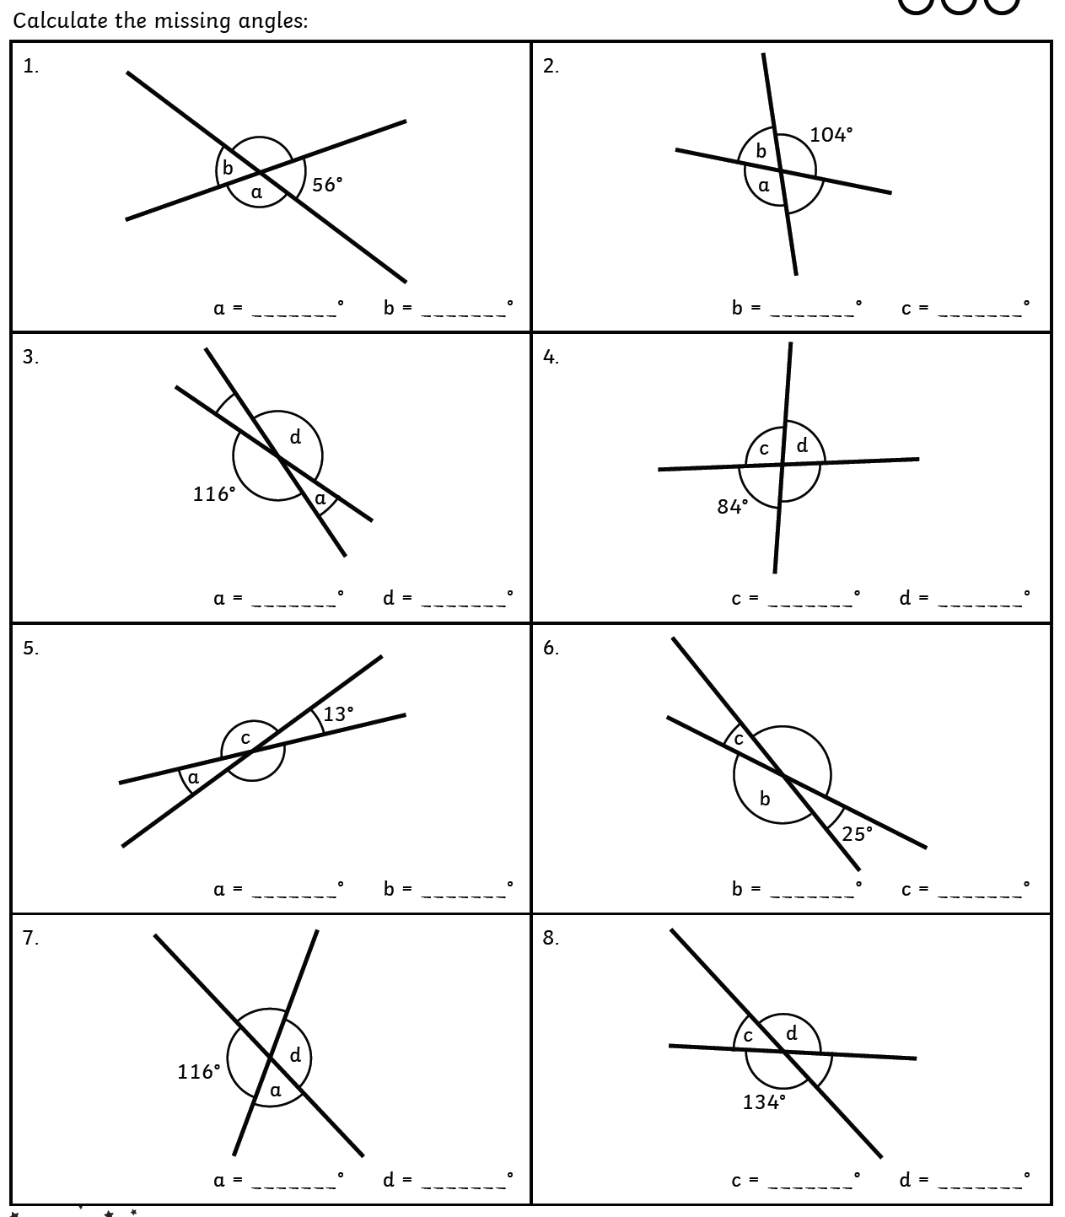
Year 6 Bronze

Find the size of each of the missing angles. Write these in your book.

