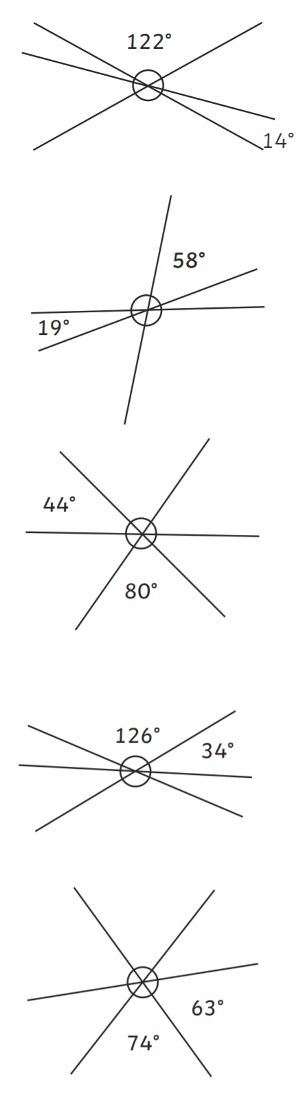

Year 6 Silver



Year 6 Silver