SEND Sheet
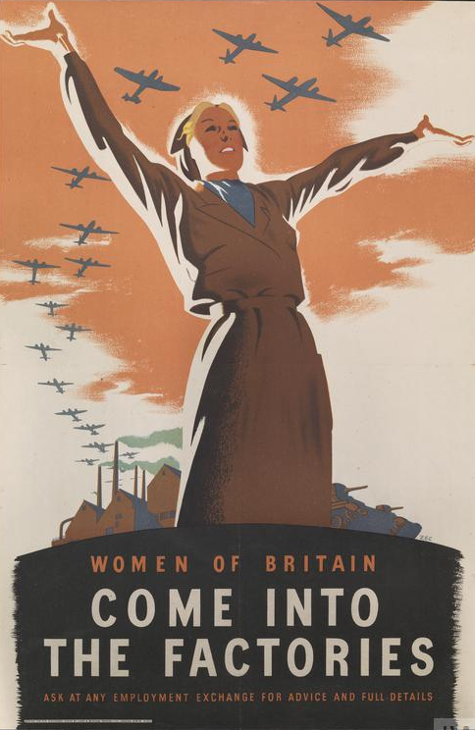

- What did Britain want women to do in the poster above?

- Name three jobs that British women did in World War II.

- Name a job that only a German woman did in World War II.

- Which job do you think was the most important that women did in World War II. Explain why you think this.

Bonus Activity

Design a propaganda poster that will persuade women to take on any of the roles that you have identified in this lesson.

