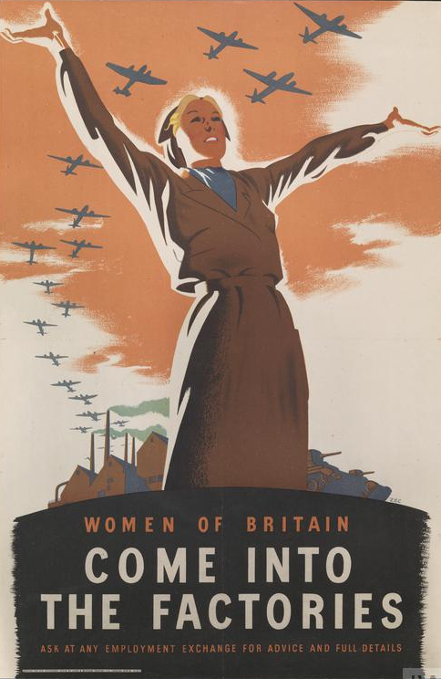
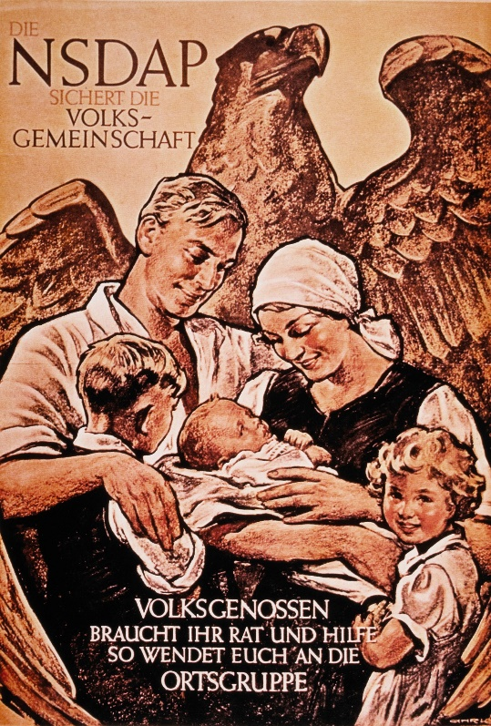

- Compare the two propaganda posters above, what impression do you get from each of them about the roles of women in Germany compared to those in Britain?

- Name three jobs that both British and German women did in World War II.

- Which role do you think was the most important that women did in World War II? Use your knowledge from today’s lesson to support your answer.

Bonus Activity

Design a propaganda poster that will persuade women to take on any of the roles that you have identified in this lesson.

