Thursday 29th April Book Talk- Additional Support
Rose Blanche by Roberto Innocenti and Ian McEwan
Lenses we have focused on:
- Fantastics: Action
- Stylistics: Yes/no relationships
- Analytics: Trawling for evidence

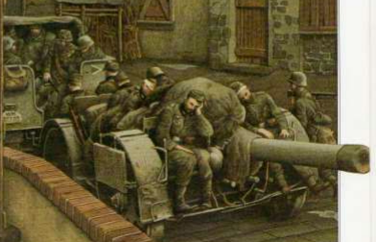
How do the soldiers feel in this picture?
The soldiers feel ______________

Because ____________-

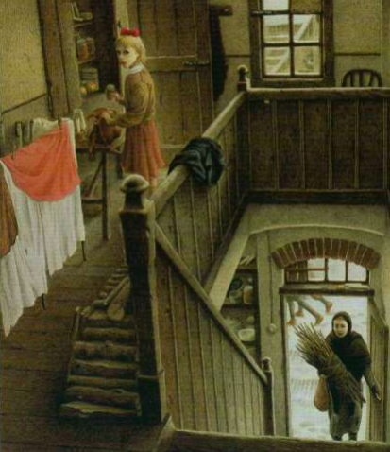
Where do you think Rose is in this picture?

Rose is in her ________ because _________

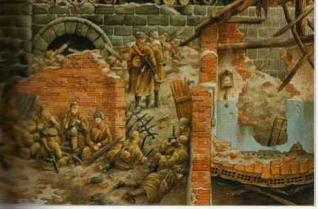 What has happened to the buildings in this picture?

The buildings have __________________________

