Tuesday 27th April Book Talk- Additional Support
Rose Blanche by Roberto Innocenti and Ian McEwan
Lenses we have focused on:
- Fantastics: Action
- Stylistics: Yes/no relationships
- Analytics: Trawling for evidence
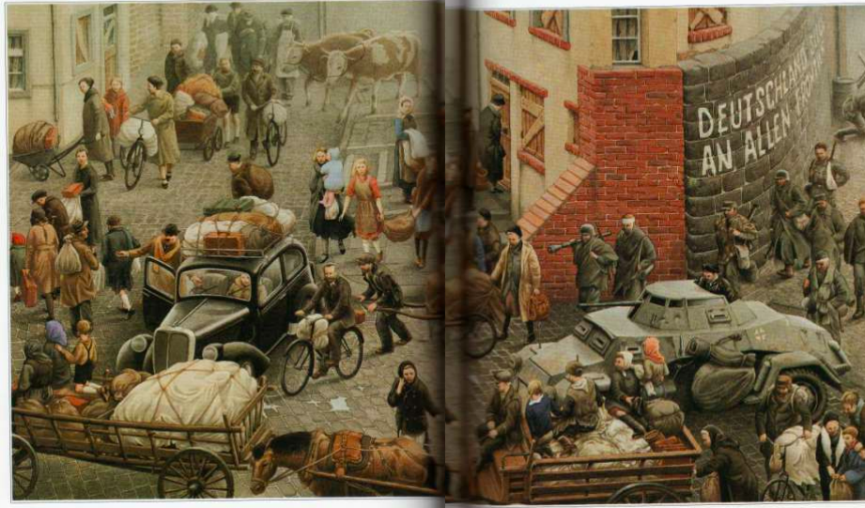
What words can you use to describe what is happening in this scene?

The action that is happening in this scene is

__________________________________________________
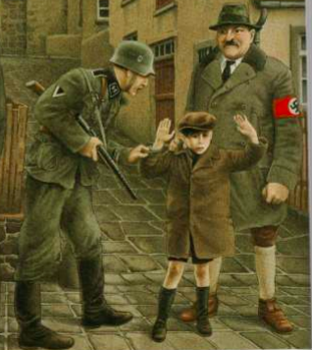 What are these three characters on slide 7?

The man on the left is __________

The boy is ____________

The man on the right is ___________

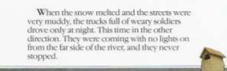On slide 16 why were the streets muddy?

The streets were muddy because

_________________________________

