Add one synonym and one antonym to each column

Reminder:
Synonym: A word that has the same or similar meaning to another word.
Antonym: A word that has the opposite meaning to another word.

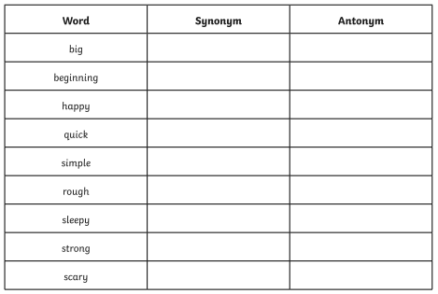

Word bank for LA:
