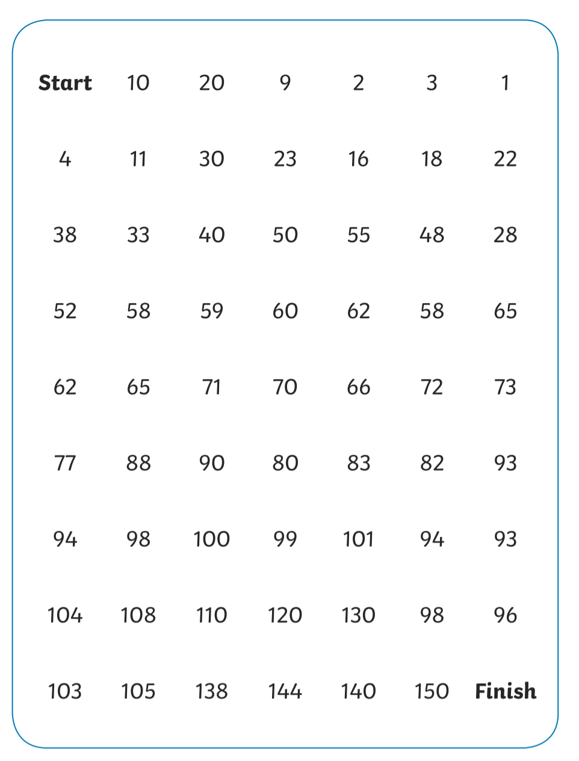
Start at the beginning of the maze and count up in 10s till you reach the finish.

Use Cuisenaire rods to find the missing numbers in these sequences. Write the answers in your book.

Q1.

33, ________, 53, ________, 73, ________, 93, ________,

Q2.

78, ________, ________, 108, ________, 128, ________,

Q3.

________, ________, ________, ________, 97, 107, 127
