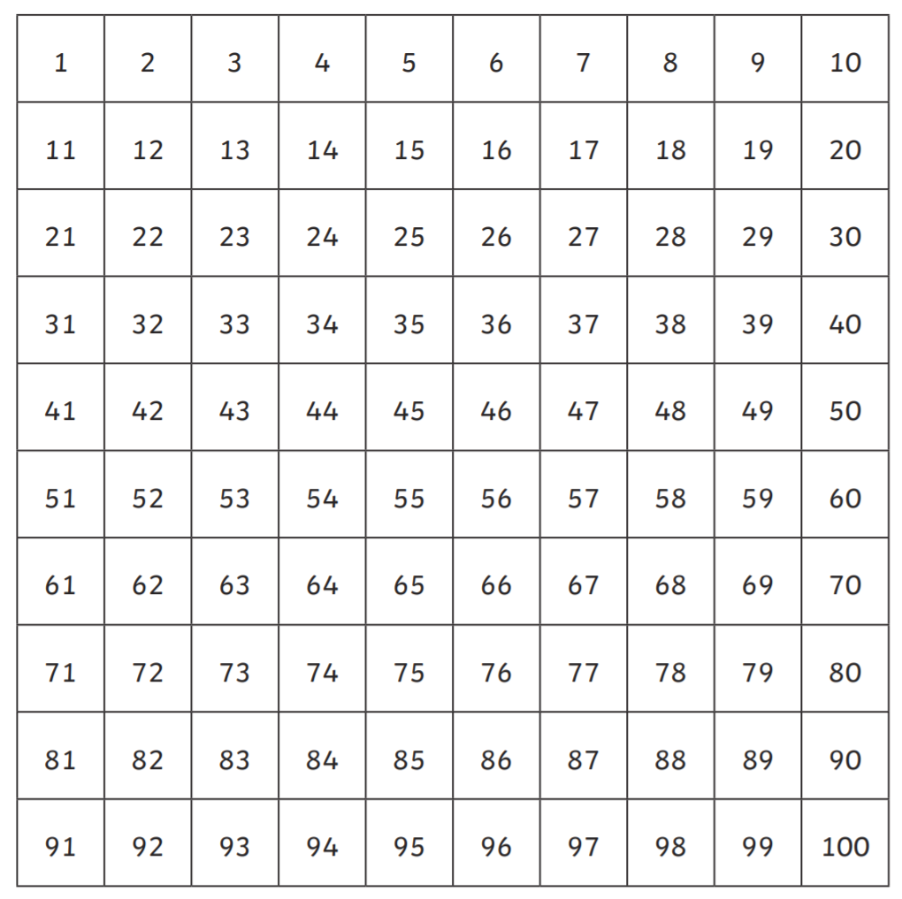
--------------------------------------------------------------------------------------------------------------------------------------
Here is a 100 square. Colour all the multiples of 2 in with one colour pencil of your choice.
Remember that multiples of 2 are even numbers and end in 0, 2, 4, 6, and 8.
Answer the following questions about the number square you have shaded in.

- What is different about the numbers that are not multiples of 2?

- Write down five numbers worth more than 100 that are also multiples of 2.
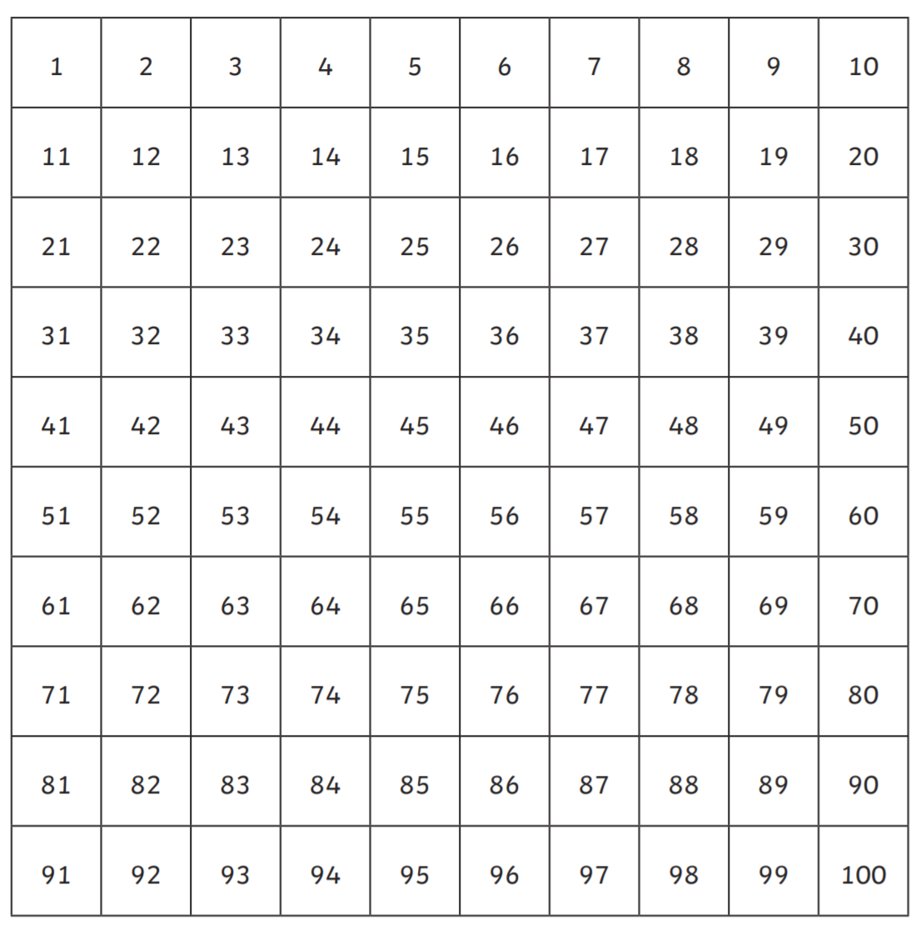
-------------------------------------------------------------------------------------------------------------------------------------
Here is a 100 square. Colour all the multiples of 3 in with one colour pencil of your choice.
Remember that multiples of 3 are odd numbers.
- Write down five numbers worth more than 100 that are also multiples of 3.

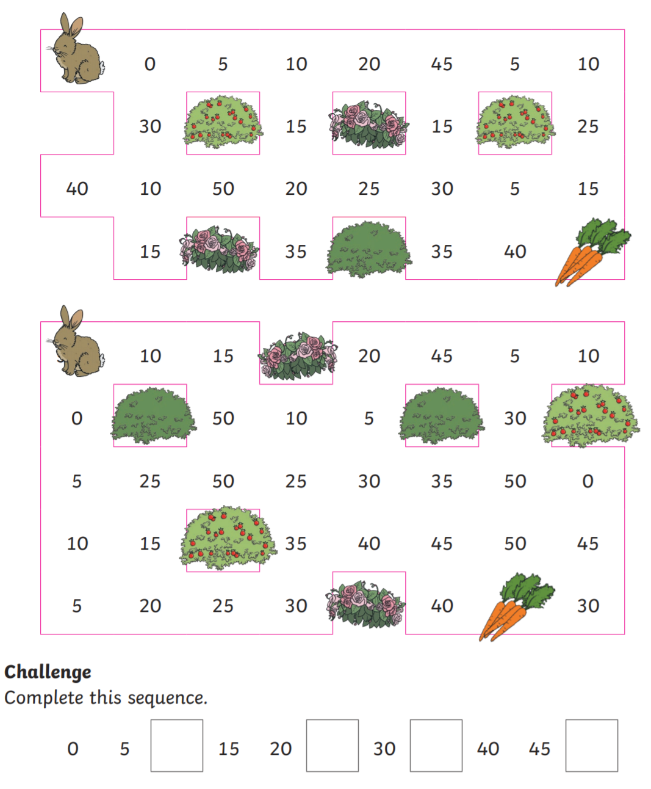
Help the rabbit find the path through the maze. Use physical resources to help you as well as number lines to check your answers.

