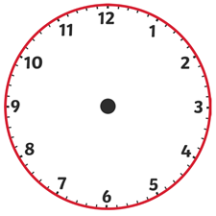

29 minutes past 4

23 minutes past 12

9 minutes to 6

17 minutes to 9

28 minutes to 11

10 minutes to 3

21 minutes past 2

3 minutes past 9

15 minutes past 8