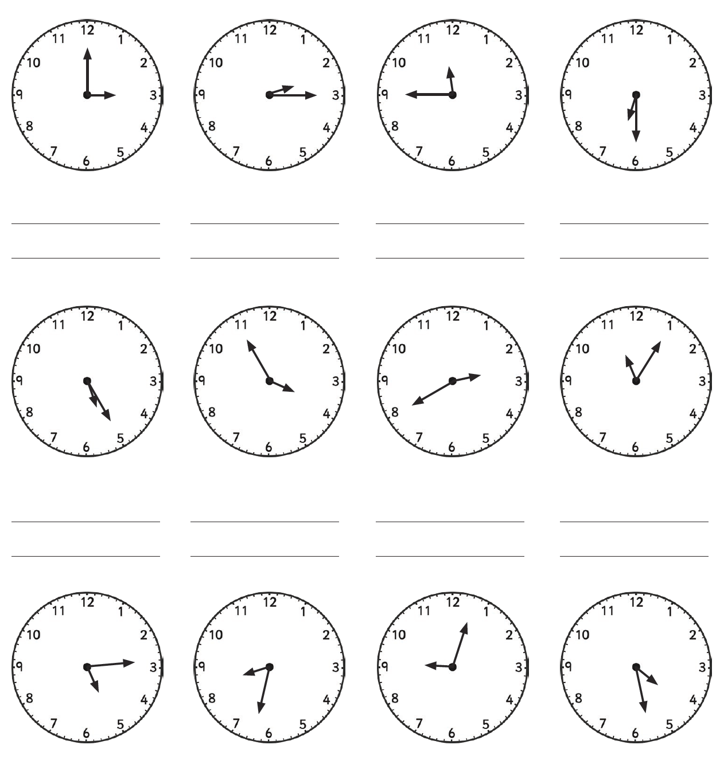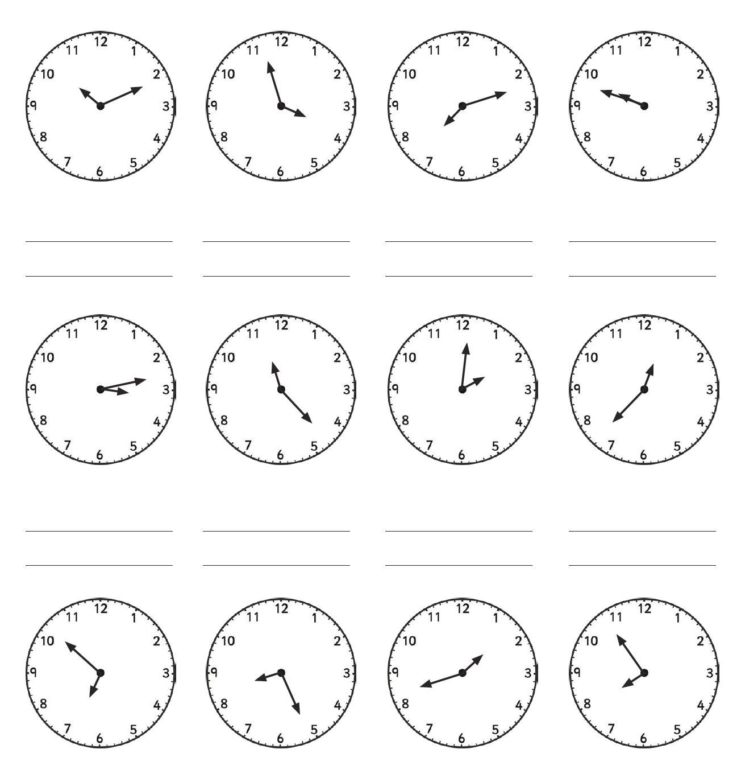

**Independent Task 1**

20

19

18

17

16

1500010

14

13

12

11

10

9

5

6

7

8

4

3

1

2

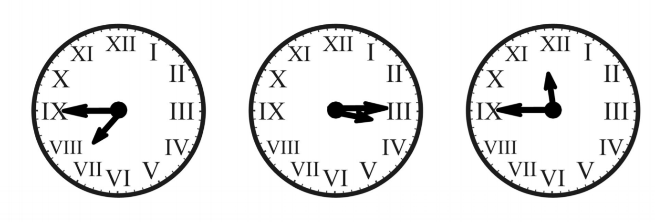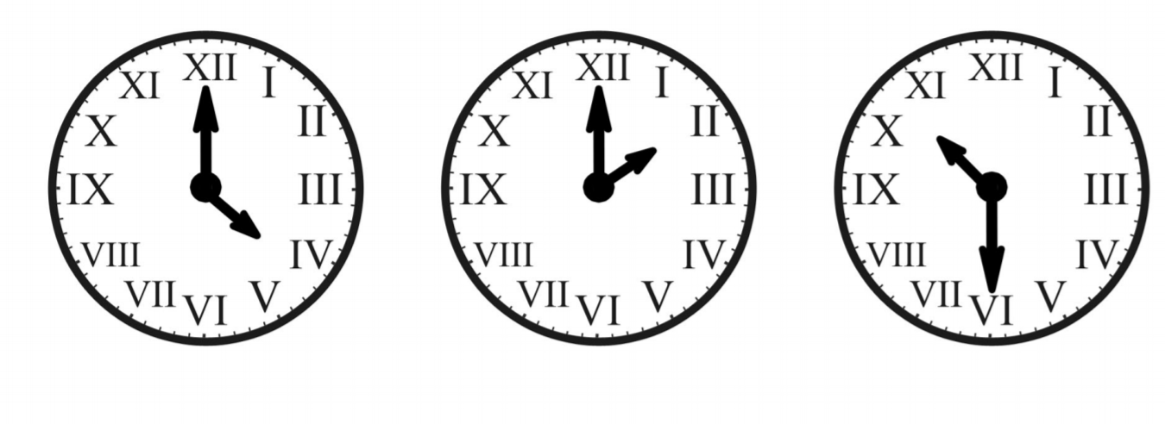 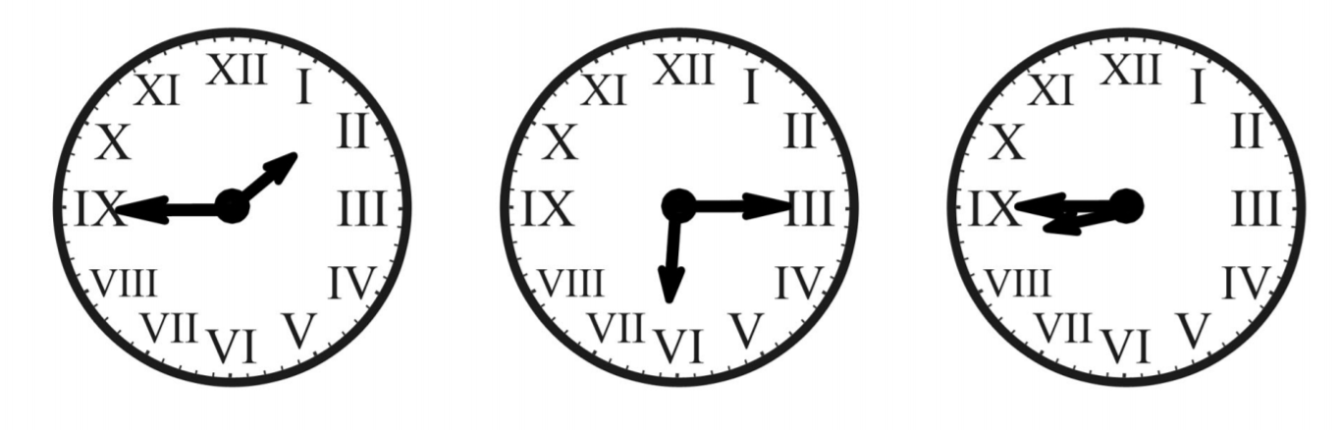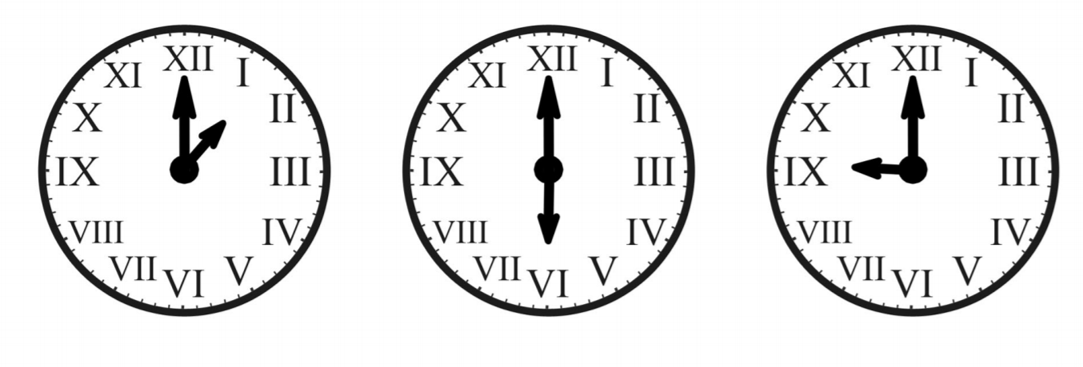

12

11

10

9

8

7

6

5

4

2

3

1

**Independent Task 2**