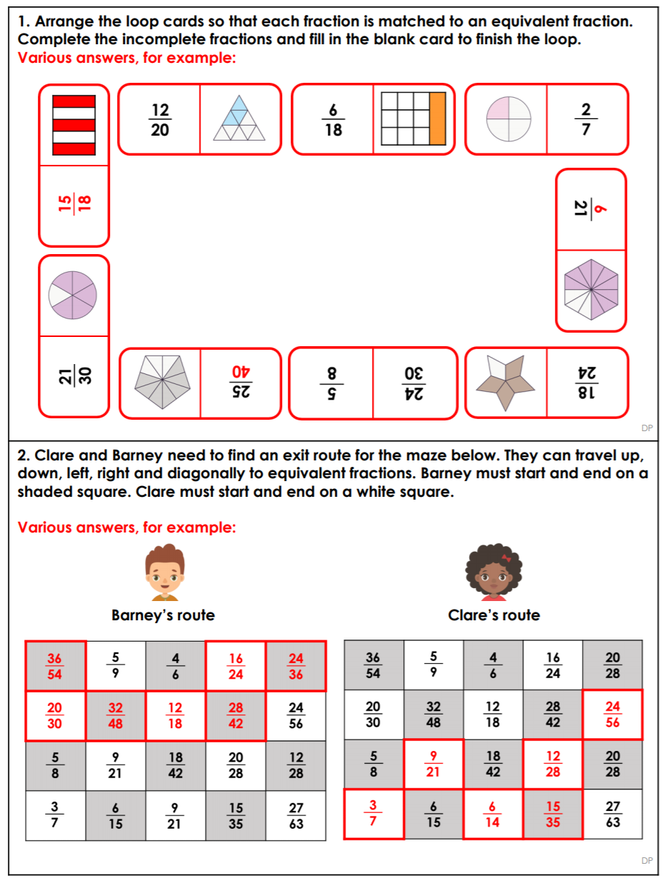
Answers – Equivalent Fraction Challenges

