Year 6 – Term 5 – Week 2 Suggested Timetable
Hola Mexico – Theme: The Ancient Maya
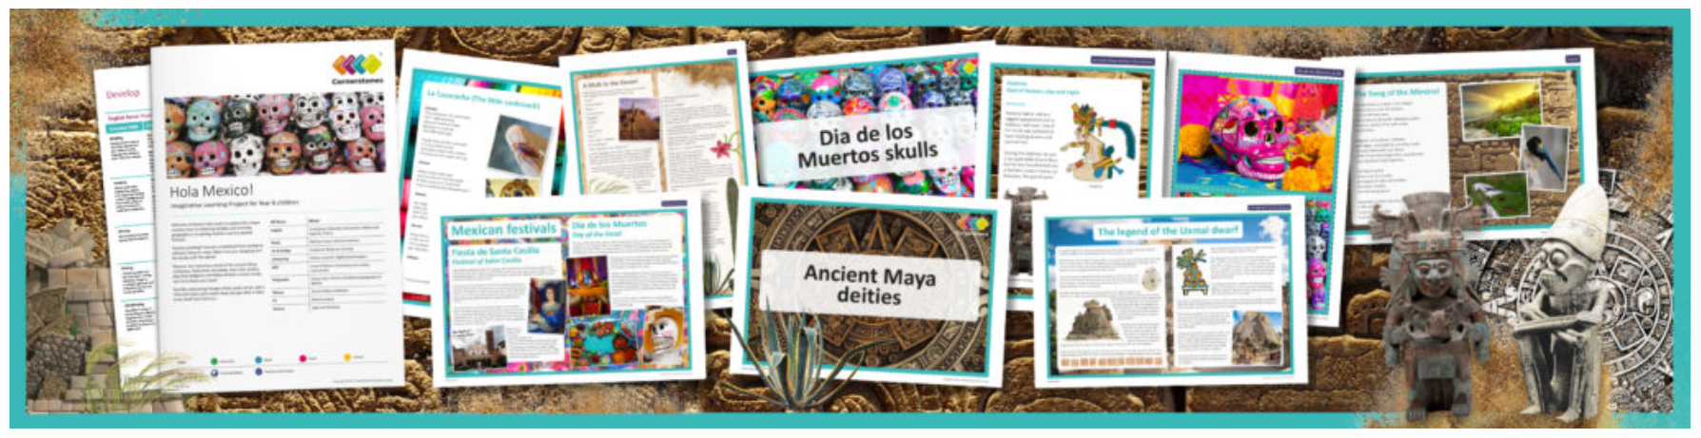
 | Monday | Tuesday | Wednesday |  | Thursday | Friday
Maths | TT Rockstars 10 mins | 2048 – 10 mins | TT Rockstars 10 mins |  | 10 mins Online maths game:  https://www.kidsmathgamesonline.com | TT Rockstars 10 mins
 | Recap from last week’s learning  CGP Book pg66-67 | Angles  CGP Book pg68-69  Powerpoint Explanation | Drawing 2D Shapes  CGP Book pg70  Area & Volume Reasoning  Powerpoint Explanation |  | Properties of Shape  CGP Book pg71-72 | 3D Shapes  CGP Book pg74-75
English Grammar, Spelling and Punctuation  Either click on the links to access new sheets or complete from your GPS booklet provided when school closed. | BBC bitesize GPS game.  Crystal Explorers  Try this exciting game and use your previously learnt GPS skills. | Grammar – 15 minutes  Using hyphens  Watch this clip  https://www.youtube.com/watch?v=1F7wFwdcfKg  Then try the activities on the PowerPoint over 2 days. | Spelling – 15 minutes  Spelling ToDo on purplemash |  | Grammar – 15 minutes  Hyphen PowerPoint. | Spelling – 15 minutes  Spelling ToDo on purplemash
English Writing | Myths and Legend! 30-45 minutes a day.  Activity 1: Use the internet to do carry out a safe search to discover a Mayan myth or legend. Find one that appeals to you and retell this to an adult.  Activity 2: Create a comic strip (or download your own-choice format from google)  Use a comic strip format to tell the legend. Decide whether to tell it in six or eight parts and consider what each frame will show. Decide whether they would like to include speech and thought bubbles as part of their illustrations. Myths and legends include the love story of Sac Nicté and Canek, or the legend of the Aluxes. |  |  | Rye Writer! – 30-45 minutes a day.  This can be accessed from the Sharks Class webpage.
Reading | 30 minutes a day  Mayan Creation Story Reading Comprehension | 30 minutes a day  The Ancient Mayan Civilisation Interactive book. | 30 minutes a day  Free reading choice from home.  Reading challenge: Ask a parent to seesaw read your book with you and time how long you can do this for! Send me your time. Seesaw reading is when you read a page and then your parent reads a page. |  | 30 minutes a day  Take ReadTheory quizzes.  Please email if you need your login sent out again. | 30 minutes a day  Free reading choice from home.  Reading challenge: Ask a parent to seesaw read your book with you and time how long you can do this for! Send me your time. Seesaw reading is when you read a page and then your parent reads a page.
Topic theme: The Ancient Maya  These can be completed in any order that you would like to try them in! | History  Look at a range of images that illustrate aspects of ancient Maya civilisation. Decide what you can find and develop a list of questions that would form a basis for further research work.  Can you create a PowerPoint, piece of writing or report on what you have discovered about the Maya civilisation?  https://www.dkfindout.com/uk/search/maya/ this is a great website to start on.  https://www.bbc.co.uk/bitesize/topics/zq6svcw/articles/zs2ph39 | Computing  Use the web to find out more about the ancient Maya writing system. Find, cut and paste examples of the Maya ‘glyphs’ into a Word document.  Note  Glyphs are the writing of the ancient Maya. The Maya were one of only three civilisations that invented a complete system of writing. Although until relatively recently, the glyphs were not understood; now the ‘Maya code’ has largely been broken and it is possible to understand much of what was written on temples, monuments, stelae and other objects made by the ancient Maya. | D.T.  Left over Easter chocolate?  Find out about the Maya chocolate making process and then make your own thick spicy drinking chocolate. Try adding orange zest, white chocolate buttons and even chilli to experiment with the taste and texture of the chocolate. Taste and enjoy!  Note  The Maya drank rather than ate their chocolate and regarded it as ‘food of the Gods’. Hieroglyphs depicting chocolate being poured for rulers and Gods can be found on Maya murals and ceramics.  Observe safety and hygiene in food preparation. |  | Science  Exercise investigation!  Why not carry out this exercise investigation whilst you’re at home?  Perhaps monitor the effects and benefits of going out for a walk or a run versus staying indoors? | Art  Choose a project this website. Remember to take pictures and upload them to your Dojo portfolio!  (We will be running this as the weekly art activity for a few weeks so you will get a chance to do more than one activity).

