Year 6 – Term 5 – Week 1 Suggested Timetable
Hola Mexico!
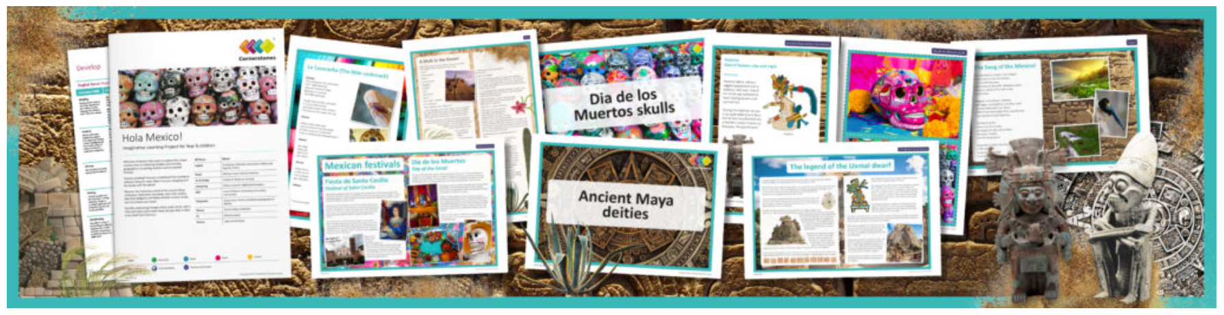
 | Monday | Tuesday | Wednesday | Thursday | Friday
Maths | TT Rockstars 10 mins | 2048 – 10 mins  https://play2048.co.uk | TT Rockstars 10 mins | 10 mins Online maths game:  https://www.kidsmathgamesonline.com | TT Rockstars 10 mins
 | Units & conversions  CGP book page 55-56 | Time & money  CGP book page 57-59 | Perimeter and area  CGP book page 61 – 62 | Areas of triangles and parallelograms  CGP book page 63 | Volume  CGP book page 64-65
English Grammar, Spelling and Punctuation  Either click on the links to access new sheets or complete from your GPS booklet provided when school closed. | Spelling – 15 minutes  Complete purplemash spelling quiz, set as a ToDo. | Grammar – 15 minutes  Using semi-colons to mark boundaries. | BBC bitesize GPS game.  Crystal Explorers  Try this exciting game and use your previously learnt GPS skills. | Grammar – 15 minutes  Using dashes to mark boundaries. | Spelling – 15 minutes  Complete purplemash spelling quiz, set as a ToDo.
English Writing | This is Mexico! Research and writing project – 30-45 minutes a day.  The learning attached to this link asks you to use the internet to research and write a comparison between our country and Mexico. |  |  | Rye Writer! – 30-45 minutes a day.  This can be accessed from our Dolphins Class page.
Reading | 30 minutes a day  Free reading choice from home.  Take a photo and share on your Dojo portfolio of you reading this in an usual place… under the stairs, in a den? | 30 minutes a day  Take ReadTheory quizzes.  Please email if you need your login sent out again. | 30 minutes a day  Indus Valley Comprehension | 30 minutes a day  Mexico Fun facts  Read the ‘Fun Facts’ and sequence them in your writing book to show the 10 you found most interesting | 30 minutes a day  Free reading choice from home.  Take a photo and share on your Dojo portfolio of you reading this in an usual place… under the stairs, in a den?
Topic theme: This is Mexico!  These can be completed in any order that you would like to try them in! | Music  Research and listen to a traditional Mexican musical performance, such as the mariachi or ranchera. What instruments can you hear? Can you recreate the beat using either instruments at home or pots and pans? Reflect on how the music makes you feel and why you think it is important to Mexican culture. | P.E.  Your challenge this week is to find the best P.E. YouTube videos to nominate for week’s P.E. Let us know via ClassDojo and the winning P.E. video will be added on to here as a link. | D.T.  Read recipes for traditional Mexican fruit drinks and choose one to make. Make a shopping list for the ingredients needed. Write your own instructions and then follow them to make fruit punches. Enjoy tasting your own drink, discussing and suggest changes to ingredients they did not like in order to improve their punches. No Mexican party is complete without a refreshing drink! | Science  Let’s revise the circulatory system!  Here is a link to two documents to help you recall the parts of the human circulatory system. Have fun making a paper model if you have access to a printer. | Art  Choose a project from the variety on the website below. Remember to take pictures and upload them to your Dojo portfolio!  (We will be running this as the weekly art activity for a few weeks so you will get a chance to do more than one activity).  https://www.deepspacesparkle.  com/category/art-lessons-by-subject/mexican-unit/

