22.2.21
Maths Meeting
Band 1
L.I: To count in 2’s, 5’s and 10’s.
S.C. I can count in 2’s, 5’s and 10’s to complete the number sequences.

Counting in 2’s.

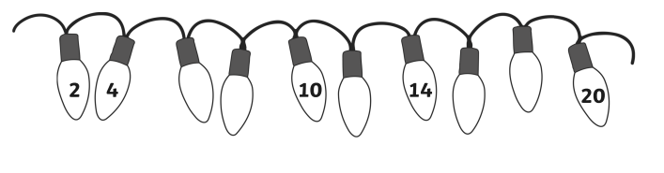

Counting in 5’s.

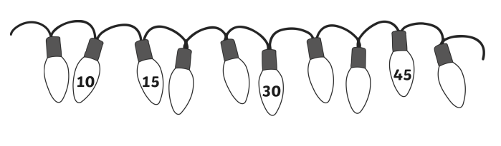

Counting in 10’s.

