19.3.21
Year 1 Task 1
L.I: To begin to punctuate with full stops and question marks.
SC: To use the correct punctuation.
*I can use a full stop correctly.
*I can use a question mark correctly.
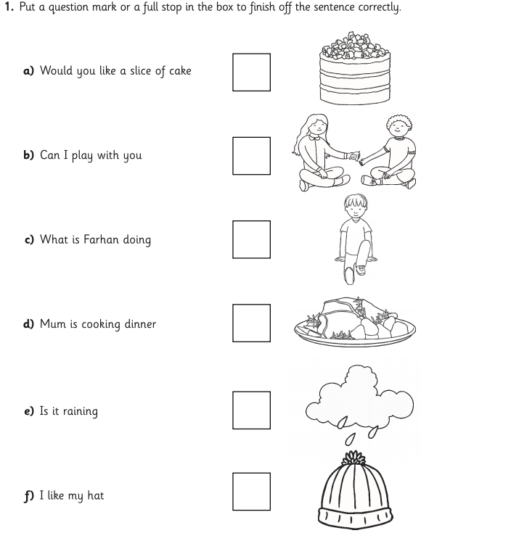

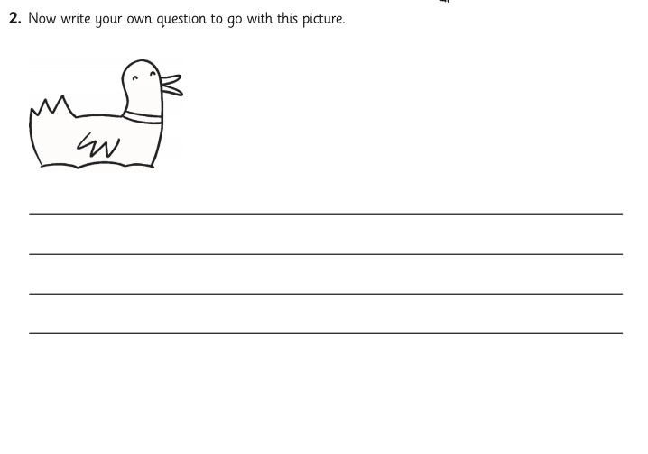

19.3.21
L.I: To use ‘and’ to join words and clauses.
SC:* I can join words and parts of a sentence using and.
*I can join two sentences using and.

