19.3.21
Year 2
L.I: To form nouns using suffixes such as –ness.
SC: *I can add the suffix –ness to adjectives to form nouns.
*I can use nouns ending in –ness in sentences.

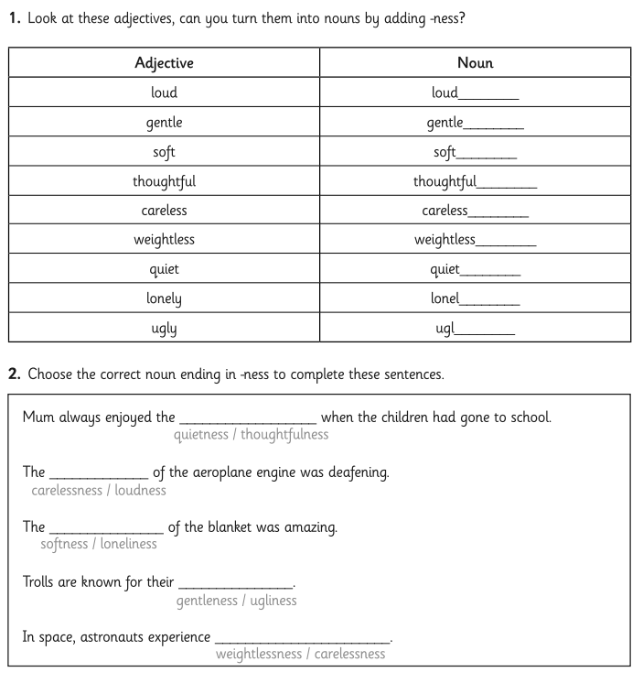
19.3.21
L.I: To use apostrophes to mark where letters are missing in spelling.
SC: *I can use an apostrophe to mark where letters are missing.

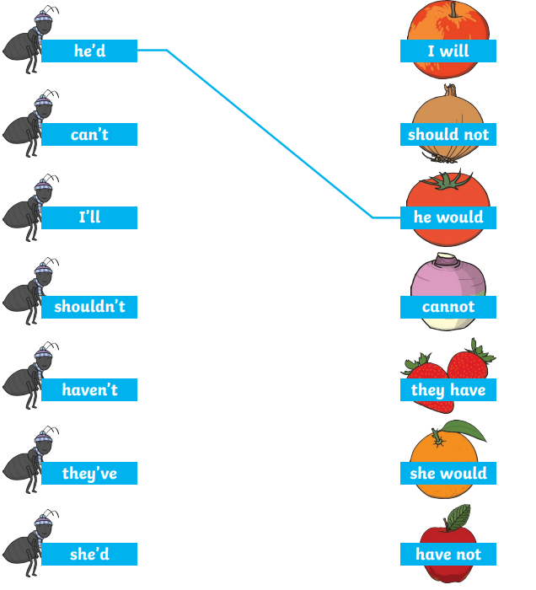

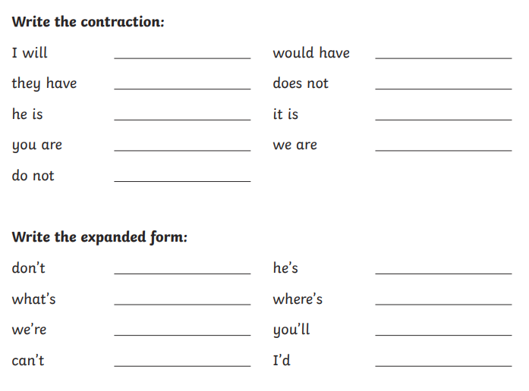

Rewrite the sentences with the contracted word.
Where is the party tomorrow afternoon?

In the cave, there is a mighty dragon.

I have always wanted a pet rabbit.

